- - - - Screenshots - - - -
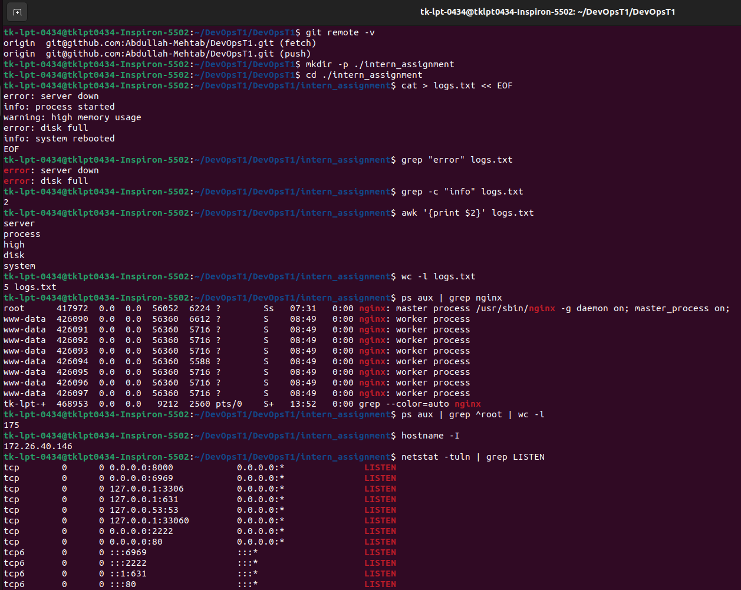
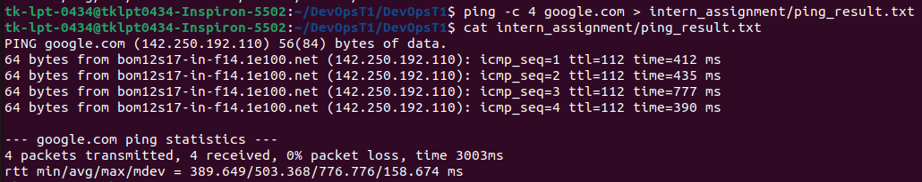
Command’s and their details inside report.txt

